How to Use:

This assumes you are using the virtual machine.

# 1.0 Navigate to twp/october in the browser

Once the client virtual machine is open navigate to twp/october, which should take you to the home page. In order to start the will process you must first log in/register by clicking one of the buttons in the top right hand corner. This page is shown below.



# 2.0 Register with the software

You should be greeted with the page below, which is the register/log in page. To begin with register yourself by entering your full name, email and a password. This page is shown below.

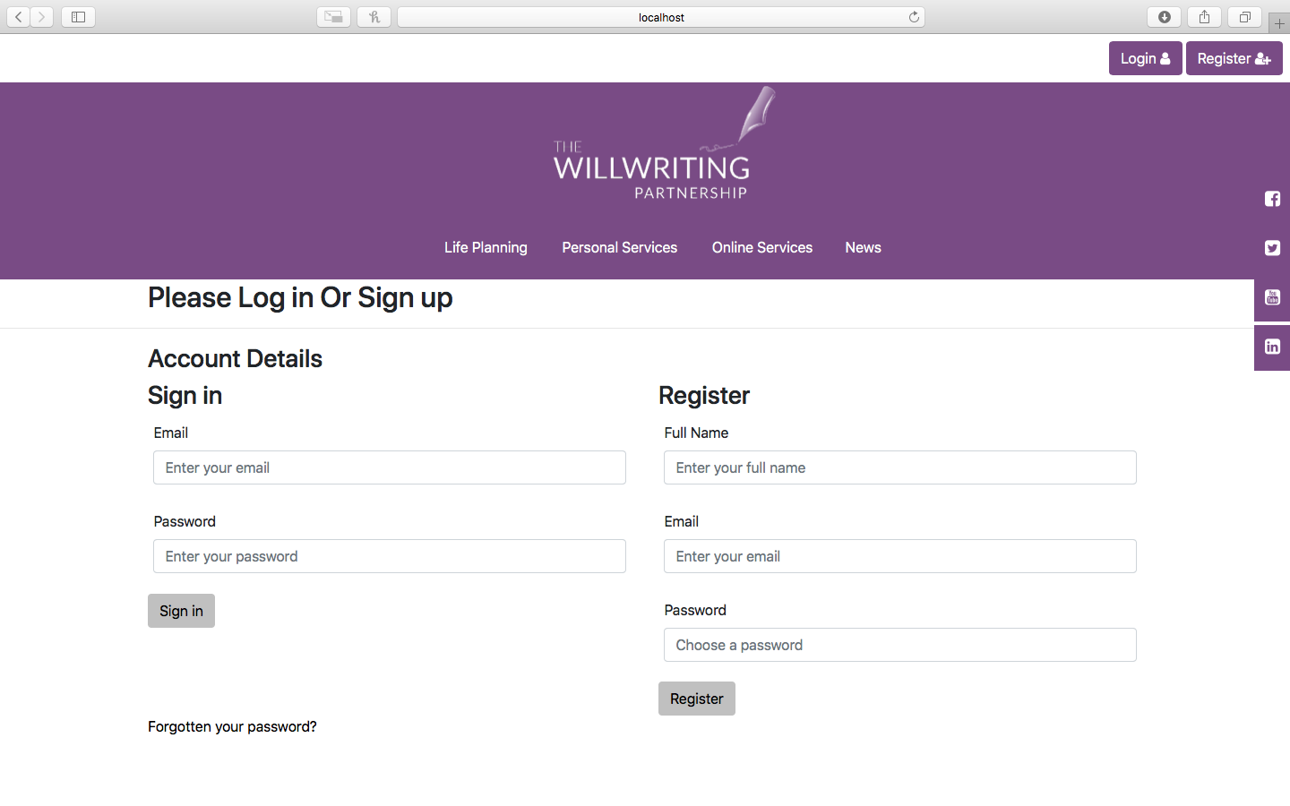

Once registered you will be taken to the user area shown below.

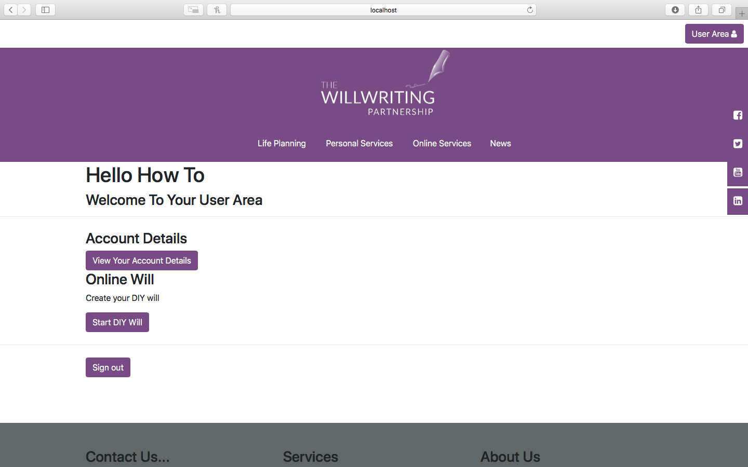

# 3.0 Will creation

By clicking the Start DIY Will button you will be taken to the first page of the DIY will. After filling out each field click the submit button. This will take you to the terms and conditions page. Shown below is the terms and conditions page, by clicking agree you can progress to the last will and testament forms. Decline will take you back to the user account page. However, at this time if you choose to decline you will have to start at the client data page.

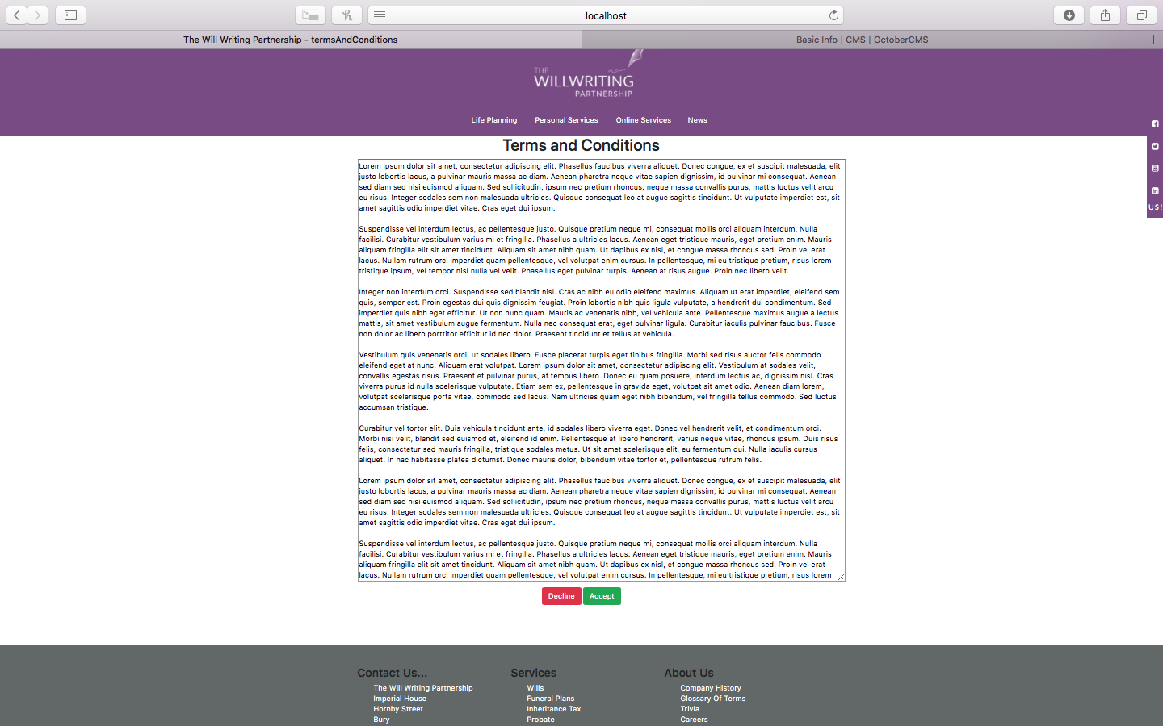

After navigating through the forms, you will be taken to the payment page shown below. Entering your name and then the following card number: 4242424242424242 along with any expiration date and security code 424. Then by submitting you will be taken to the 3d secure test authentication. This page is shown below.

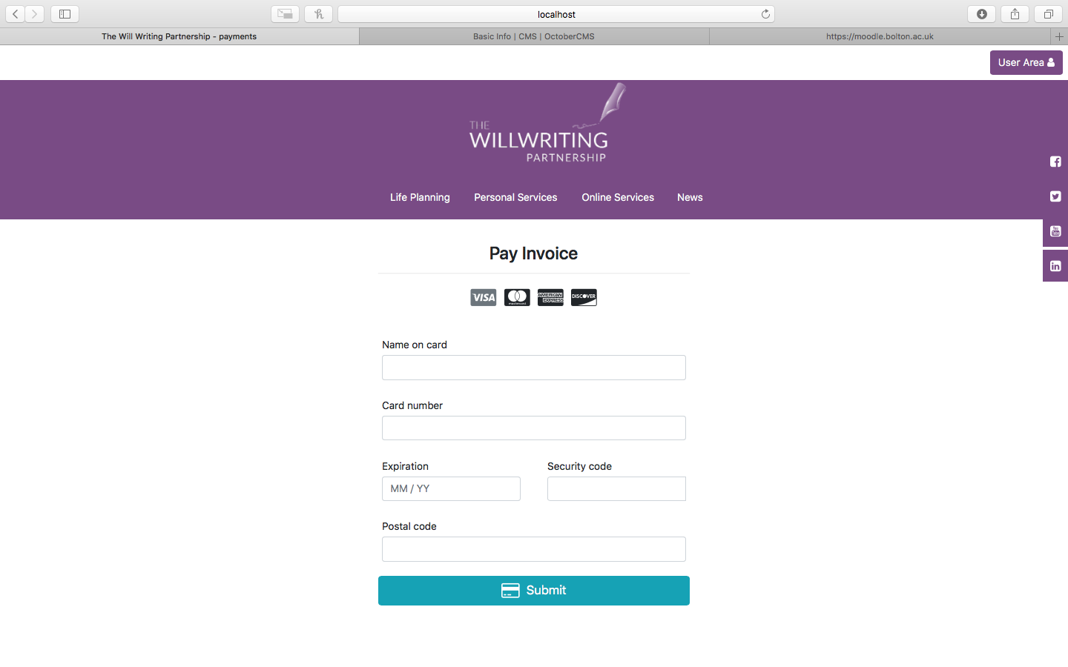

Click continue will allow you to progress to the next 3d secure page. This page is shown below.

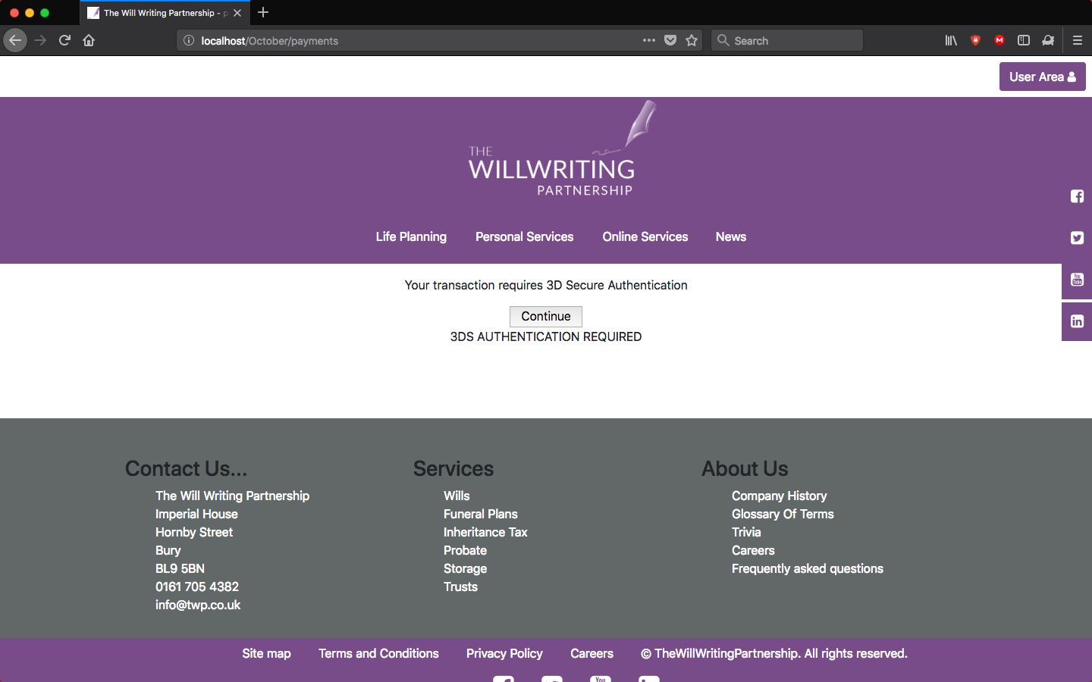

Here you will need to select status: Y: Successful Authentication, which will then return you to the October site. This page is shown below.

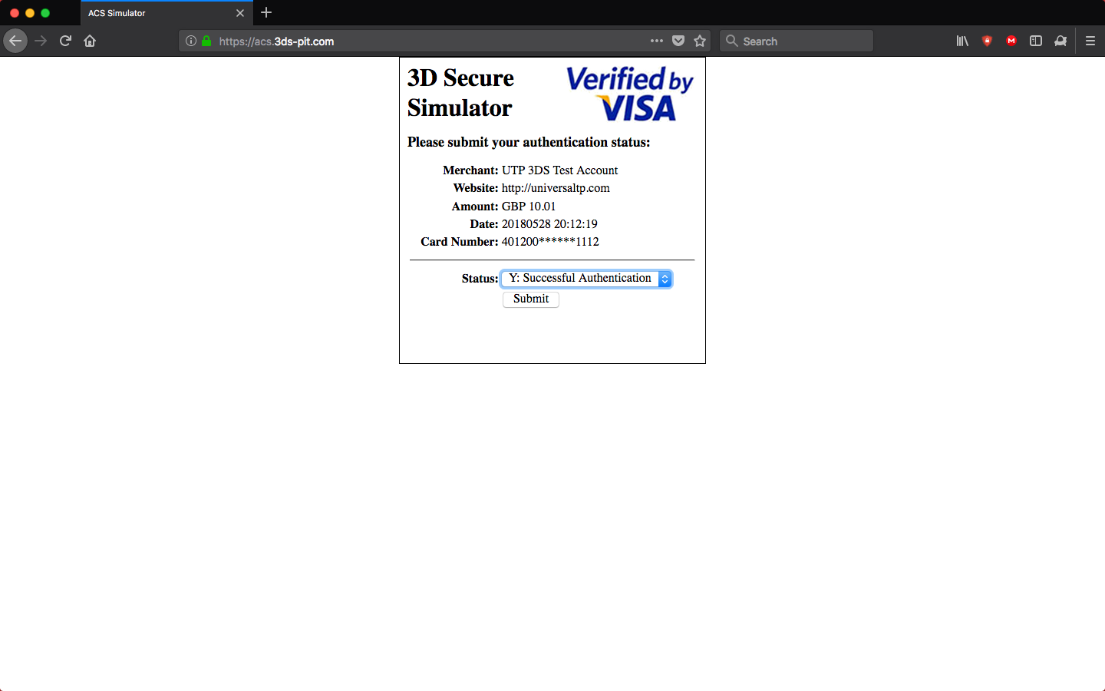

One submitted you will be taken to the thank you for paying page, which allows you to get your pdf will. Clicking the get will button will allow you to download the pdf.

And the back to user area button will return you to your user area. This page is shown below.

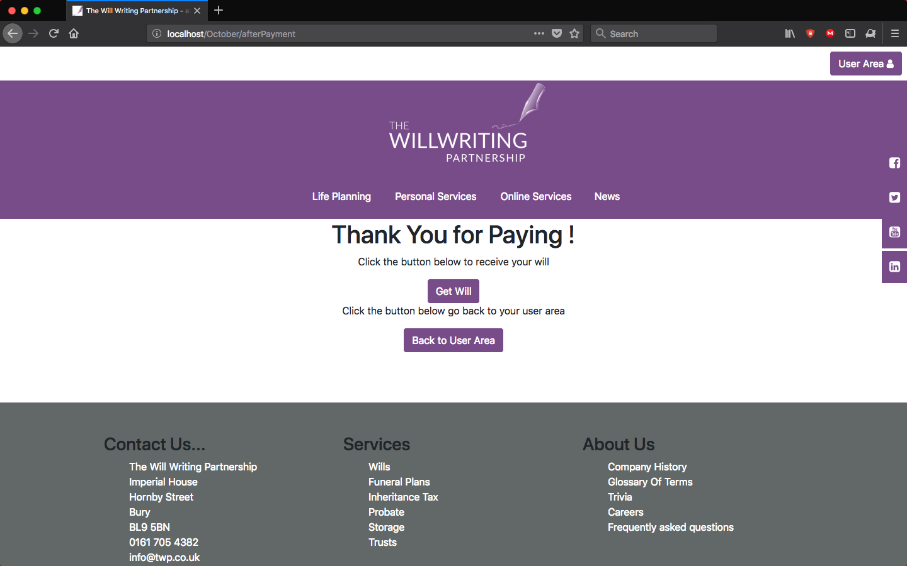

Going back to the user area, it will become apparent that you can no longer start a new will. Instead it will allow you to redownload your created will. Shown below is the updated user area.

